

**REPUBLIC OF CAMEROON**

**Peace-Work-Fatherland**

**MINISTER OF HIGHER EDUCATION**

**FACULTY OF ENGINEERING**

**AND TECHNOLOGY**

**REPUBLIQUE DU CAMEROON**

**PAIX-Travail-Patrie**

**MINISTRE DE L’ENSEIGNEMENT SUPERIEUR**

**FACULTE D’INGINERIE**

**ET TECHGNOLOGIE**

***\*\*\*\*\*\*\*\*\*\*\*\*\*\*\*\*\*\*\*\*\** UNIVERSITY OF BUEA *\*\*\*\*\*\*\*\*\*\*\*\*\*\*\*\*\*\*\*\*\*\*\*\****

**COURSE TITLE: INTERNET PROGRAMMING AND MOBILE PROGRAMMING**

**PROJECT: DESIGN AND IMPLEMENTATION OF A BIOMETRIC STUDENT'S ATTENDANCE MOBILE APPLICATION**

**TASK FOUR : SYSTEM MODELLING AND DESIGN**

**COURSE CODE: CEF 440**

**PRESENTED BY:**

|  |  |
| --- | --- |
| **NAME** | **REGISTRATION NUMBER** |
| **IHIMBRU ZADOLF ONGUM** | **FE21A203** |
| **CHE KASSINA KUM** | **FE21A158** |
| **NFOUA EUGENE MGBA** | **FE21A257** |
| **FONJI DANIEL KUKUH** | **FE21A194** |
| **EPIE MUKEH SANDRA** | **FE21A185** |

**COURSE FACILITATOR: APRIL 2024**

**Dr. VALERY NKEMENI**

Table of Contents

1. Introduction 2

1.1 Overview 2

2. Context diagram 2

2.2 Stakeholders and Their Specific operations 2

Figure 1: Context diagram of a biometric fingerprint attendance system 4

3. Use case diagram 4

3.2 Actors and Their Specific Use Cases 5

3.3 Relationships Between Use Cases 6

FIGURE 5: Use case diagram of a biometric fingerprint attendance system 7

4. Class diagram 7

4.1 Classes, attributes and methods relationships 8

Figure 3: Class diagram of a biometric fingerprint attendance system 8

5. Sequence diagram 9

5.1 Sequence OF OPERATIONS FOR THE BIOMETRIC ATTENDANCE 9

Figure 4: Sequence diagram of a biometric fingerprint attendance system 11

6. Deployment diagram 12

6.2 Components AND INTERACTIONS OF A FINGERPRINT ATTENDANCE SYSTEM 12

6.2.1 Connections AND DATA FLOW 13

Figure 5: Deployment diagram of a biometric fingerprint attendance system 14

Conclusion 14

**References** 15

# 1. Introduction

The system modeling and design phase is a crucial stage in the software development life cycle, where the conceptualized system from the analysis phase is transformed into a detailed and organized structure. This phase involves defining the architecture, components, modules, and data for a system to satisfy specified requirements. In the context of our quality biometric attendance system, the system modeling and design aims to provide a blueprint for implementing the envisioned features and functionalities, ensuring a scalable, maintainable, and high-quality software solution.

## 1.1 Overview

The Biometric Attendance System efficiently tracks and manages attendance using biometric data gotten from the registration process. The context diagram highlights the interactions between users and the system. The use case diagram details the system's functionalities for different users. The class diagram defines the system's structure. The sequence diagram outlines the process of marking attendance. Finally, the deployment diagram shows the physical setup of the system components

# 2. Context diagram

A context diagram focuses on how external entities interact with a system. It’s the most basic form of a data flow diagram, providing a broad view of the system and its interactions with external entities in an easily digestible way. Because of its simplicity, it’s sometimes called a level 0 data flow diagram.

### 2.2 Stakeholders and Their Specific operations

**ADMINISTRATOR:**

* **Login:** Administrator can login into the system.
* **Add/Manage Students:** Administrator can add/manage students in the system.
* **Add/Manage Teachers:** Administrator can add/manage teachers in the system.
* **Manage attendance:** Administrator canview, update, and report on attendance records, and set attendance policies**.**
* **Generate report:** Administrator **can** generate a detailed document that summarizes attendance data over a specified period from the biometric device,
* **Logout:** Administrator can logout of the system.

**TEACHER:**

* **Login:** Administrator can login into the system.
* **Initiate attendance**: Teacher can start the attendance for the specific session or class.
* **Manage attendance:** Administrator canview, update, and report on attendance records, and set attendance policies
* **Generate report:** Teacher can generate a detailed document that summarizes attendance data over a specified period from the biometric device.
* **Logout:** Teacher can logout of the system.

**STUDENT:**

* **Mark attendance:** student can record their presence for the specific session.
* **Track attendance:** student can monitor and analyze the attendance data over time to identify patterns, trends, and issues.

**Figure 1** below shows a context diagram of a biometric fingerprint attendance system

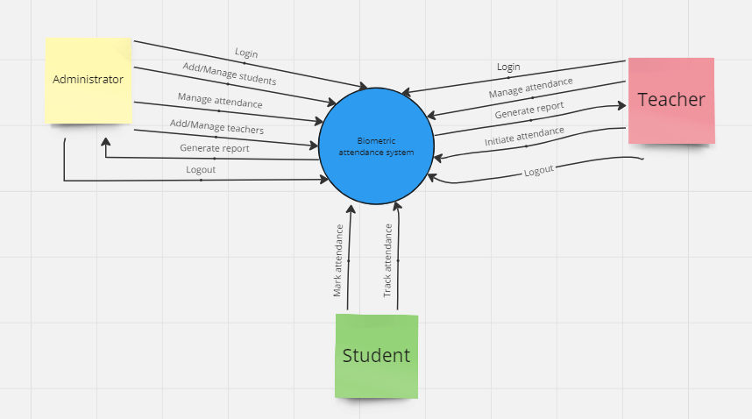

### Figure 1: Context diagram of a biometric fingerprint attendance system

# 3. Use case diagram

A Use Case Diagram is a vital tool in system design, it provides a visual representation of how users interact with a system. It serves as a blueprint for understanding the functional requirements of a system from a user’s perspective, aiding in the communication between stakeholders and guiding the development process. The main components of a use case diagram include actors, use cases, and the relationships between them.

This use case diagram for the Biometric Student Attendance System encompasses four main actors: Students, Lecturers, Admins, and the Email Messaging Provider. Each actor has specific use cases that outline their interactions with the system. The diagram highlights the relationships between these use cases, showing how some use cases extend others, and how some are included as part of larger processes. The Email Messaging Provider, while external, plays a crucial role in communicating attendance information to both students and lecturers.

## 3.2 Actors and Their Specific Use Cases

**STUDENT (primary actor)**

* Mark Attendance**:** Students use the biometric system to mark their attendance.
* Receive Attendance Status: Students receive their attendance status after marking attendance.

**TEACHER (primary actor)**

* Login: Lecturers log into the system.
* Activate Attendance Session: Lecturers initiate the attendance session for students to mark their attendance.
* View Attendance List: Lecturers view the list of students' attendance.
* Receive Attendance Report: Lecturers receive detailed attendance reports.
* Manage Attendance Report: Lecturers manage attendance reports, which may include editing or analyzing attendance data.
* Mark Attendance for Students: In some cases, lecturers can mark attendance of students

**ADMINISTRATOR (secondary actor)**

* Login: Admins log into the system.
* View Attendance List: Admins can view the attendance list.
* Receive Attendance Report: Admins receive detailed attendance reports.
* Manage Attendance Report: Admins manage attendance reports.
* Register New Student: Admins register new students into the system, including capturing their biometric data and school information.
* Register Lecturers: Admins register new lecturers into the system.
* Add and Edit Lecturer Sessions: Admins can add and edit lecturer sessions.

**EMAIL MESSAGEING PROVIDER (tertiary actor)**

* Send Attendance Emails: This external system/service is responsible for sending attendance emails to students and lecturers.

## 3.3 Relationships Between Use Cases

**Extensions**

* **Receive Attendance Status**: This extends the **Mark Attendance** use case. After marking attendance, the student receives their attendance status.
* **View Attendance List**: This extends the **Manage Attendance Report** use case. Viewing the attendance list is a part of managing the attendance report.

**Inclusions**

* **Store Student Biometric Data**: This is included in the **Register New Student** use case. Registering a new student requires storing their biometric data.
* **Add and Edit Lecturer Sessions**: This is included in the **Register Lecturers** use case. Registering lecturers includes managing their session details.

**Figure 2** below shows a use case diagram of a biometric attendance system

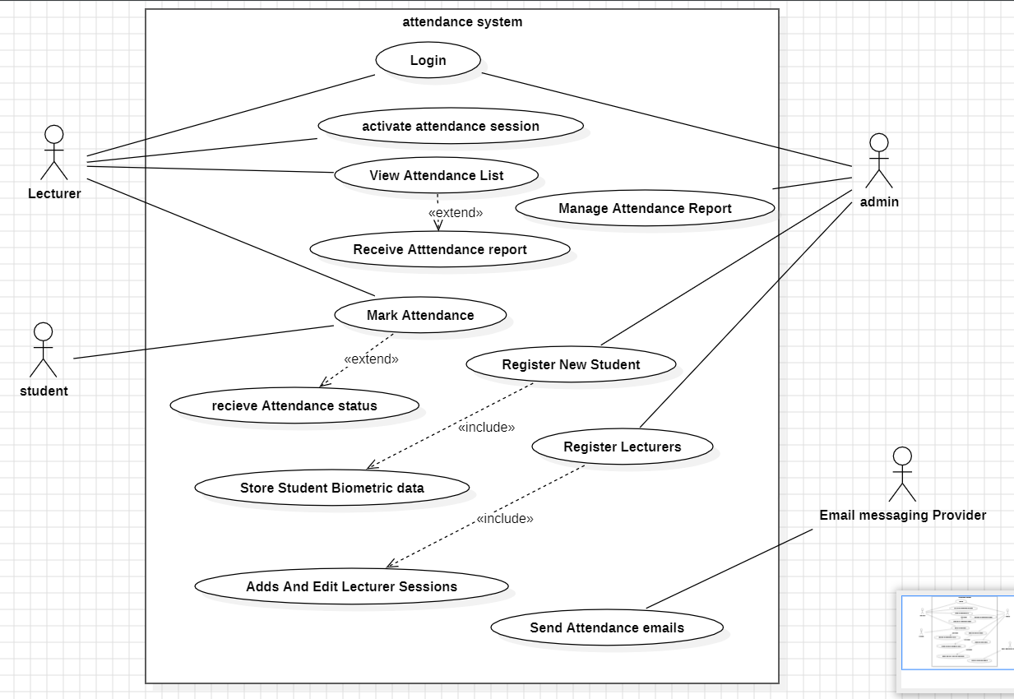

### FIGURE 5: Use case diagram of a biometric fingerprint attendance system

# 4. Class diagram

The class diagram represents the static structure of the system by showing classes, their attributes, relationships, and methods. In the context of the biometric attendance system, classes might include student, teacher. The relationships between these classes illustrate how data is organized and associated within the system. This diagram aids in understanding the data structure and forming the basis for coding the system.

## 4.1 Classes, attributes and methods relationships

**Figure 3** below shows the class diagram of a biometric attendance system

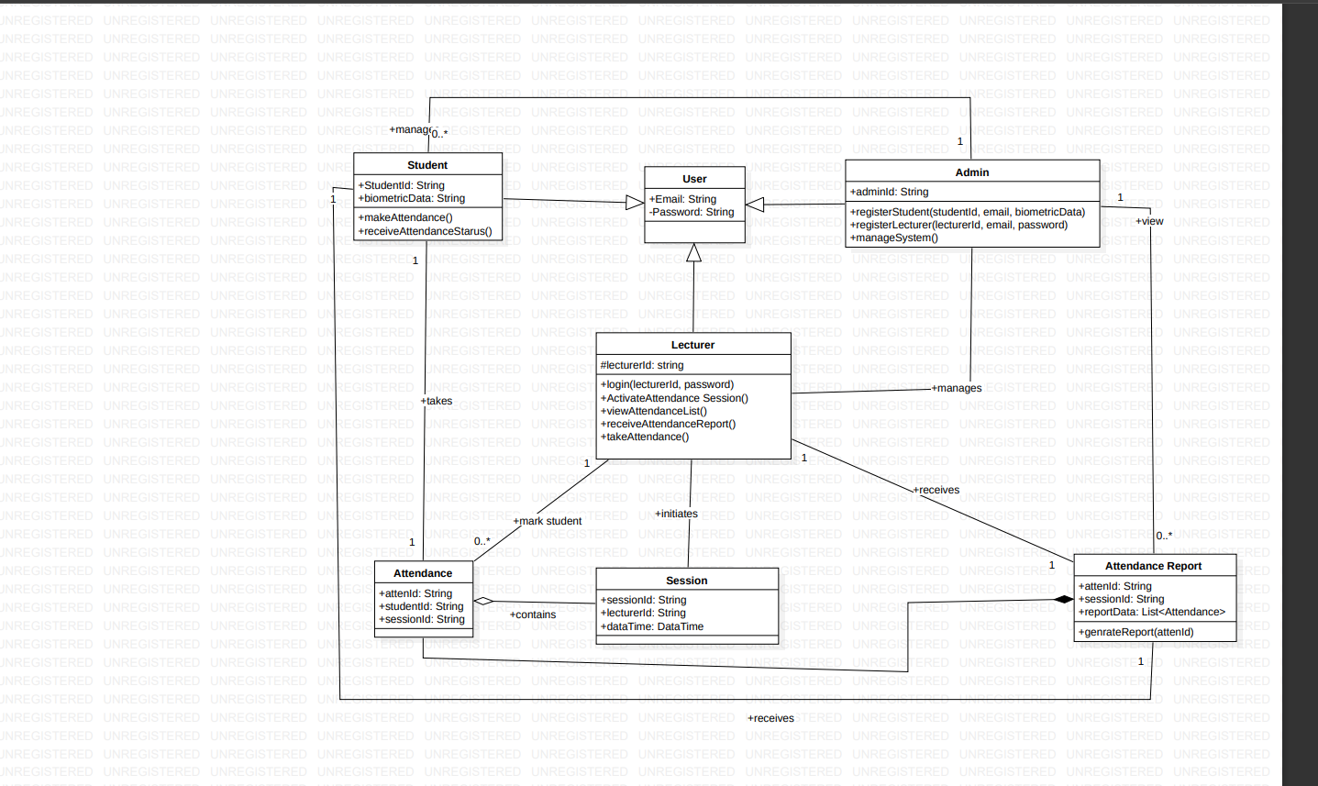

### Figure 3: Class diagram of a biometric fingerprint attendance system

# 5. Sequence diagram

The sequence diagram illustrates the process and flow of interactions between various components of the system as a student marks their attendance. It shows the sequence of messages exchanged between actors (such as students), the biometric device, the attendance system, and the database.

## 5.1 Sequence OF OPERATIONS FOR THE BIOMETRIC ATTENDANCE

**Login Process:**

* Admin and Lecturer login:
  + Admin sends login credentials.
  + System verifies credentials.
  + Admin accesses the dashboard.
  + Lecturer sends login credentials.
  + System verifies credentials.

**Initiate Attendance:**

* Lecturer initiates session:
  + Lecturer triggers attendance session.
  + System prepares to accept biometric inputs.

**Record Attendance:**

* Student authentication:
  + Student places fingerprint on biometric device.
  + System validates fingerprint.
  + If valid, attendance is recorded.
  + If invalid, retry or manual verification is requested.

**Generate and Send Reports:**

* Generate attendance report:
  + System generates comprehensive report.
  + Report is sent to Lecturer's email.
  + Individual records sent to respective student WhatsApp groups.

**Admin Dashboard:**

* Admin monitoring:
  + Admin accesses dashboard.
  + Views attendance reports.
  + Manages timetable and courses.

**Automatic Course Update:**

* Periodic course update:
  + System updates course for next period based on stored timetable.

**Figure 4** below shows the sequence diagram of a biometric attendance system

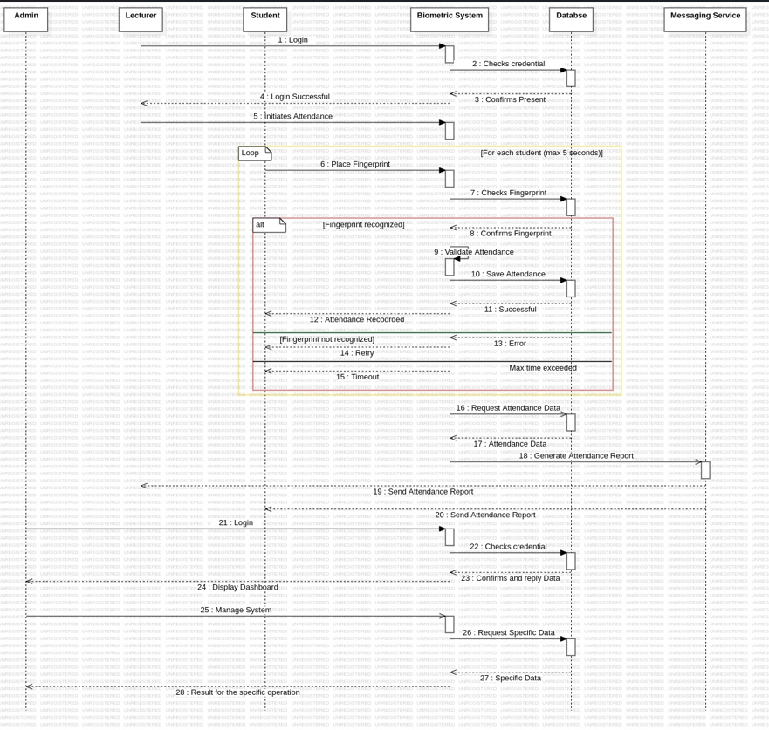

### Figure 4: Sequence diagram of a biometric fingerprint attendance system

# 6. Deployment diagram

The deployment diagram shows how various hardware and software components of our Biometric Attendance System are deployed across different physical nodes. Which includes client devices, biometric devices, application servers, database servers, and the network infrastructure. The diagram illustrates the interactions and communication paths between these components, providing a comprehensive view of the system's physical architecture and deployment.

## 6.2 Components AND INTERACTIONS OF A FINGERPRINT ATTENDANCE SYSTEM

**Database Server**

* + Stores fingerprint templates and attendance records.
  + Role: Data storage.

**Server**

* + Manages core system functionalities.
  + Includes fingerprint matching algorithm, attendance application, and configuration files.
  + Role: Core processing and coordination.

**Fingerprint Scanner (Single Device)**

* + Device for scanning fingerprints.
  + Connected to the Server.
  + Runs fingerprint scanner software.
  + Role: Input device.

**Lecturer Device (Single Device)**

* + Device for lecturer or administrator access.
  + Connects to the Server.
  + Accesses Attendance Application and Configuration files.
  + Role: User interface for system management.

## 6.2.1 Connections AND DATA FLOW

**Fingerprint Data Flow**

* + Fingerprint Scanner Device sends fingerprint data to the Server.
  + Server matches fingerprint data against stored templates in the Database Server.

**Attendance Record Processing**

* + Attendance Application on the Server processes attendance records.
  + Updates Database Server with processed attendance data.

**Lecturer Access**

* + Lecturer Device connects to the Server.
  + Accesses Attendance Application and Configuration files for system management.

**Configuration Management**

* + Configuration files shared between Server and connected devices (Fingerprint Scanner and Lecturer).
  + Ensures consistent system settings across devices.

**Figure 5** below shows the diagram of a biometric attendance system.

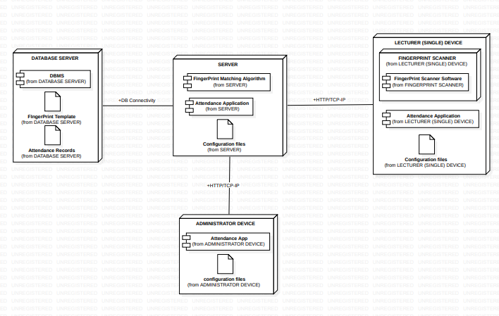

### Figure 5: Deployment diagram of a biometric fingerprint attendance system

## Conclusion

The system modeling phase transforms of my biometric fingerprint attendance system conceptualized ideas into a structured blueprint via context, use case, class, sequence, and deployment diagrams.

These visual aids elucidate the system's architecture, functionalities, and physical deployment, offering clarity and direction.

Together, these diagrams form a comprehensive guide for scalable, maintainable, and quality biometric attendance system implementation.

Leveraging these representations ensures alignment with stakeholder needs and fosters efficient system development, yielding a robust attendance management solution.

## **References**

* <https://miro.com/welcomeonboard/QlVFdnVDN0d1RWlpcEtPRjB4TzVFVERuZ1dVa0FMaHJ3S3htR21iYUpWY2xScHBlektPOFd4WTkxVWNIWElpcHwzNDU4NzY0NTkwMDA2Njg4MzE1fDI=?share_link_id=509600992838>
* https://www.google.com/amp/s/www.geeksforgeeks.org/use-case-diagram/amp/